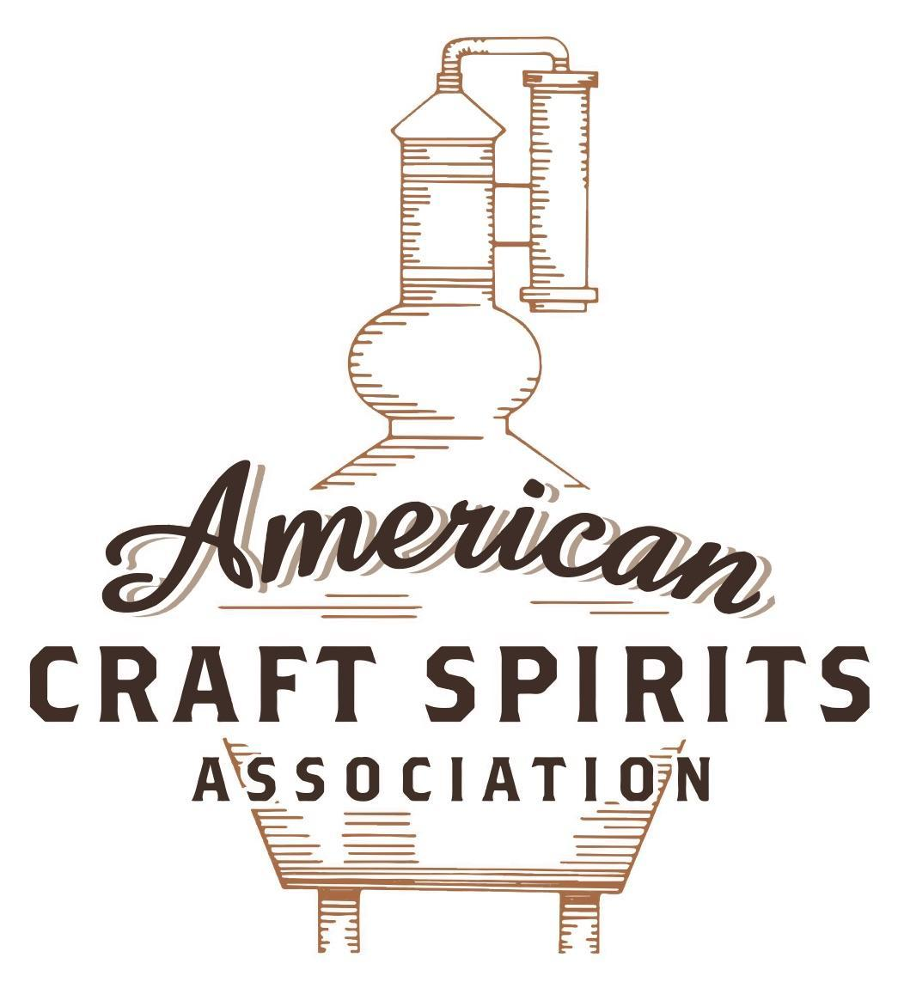
Spirits DtC Shipping Guide

This guide summarizes the direct-to-consumer shipping rules for distilleries in all 50 states and D.C. and also addresses the measures state governments have taken to ease delivery and shipping restrictions during the COVID-19 pandemic.

DtC Quick Guide Comparison

Out-of-State Distilleries  Can Ship Into State? |  |  |  | In-State Distilleries  Can Ship Within State?
State | Yes | No |  | State | Yes | No
AL |  | X |  | AL |  | X
AK | X |  |  | AK | X
AZ | X |  |  | AZ | X
AR |  | X |  | AR |  | X
CA |  | X* |  | CA |  | X*
CO |  | X |  | CO |  | X
CT |  | X* |  | CT |  | X
DE |  | X |  | DE |  | X
DC | X |  |  | DC | X
FL |  | X |  | FL |  | X
GA |  | X |  | GA |  | X
HI |  | X* |  | HI |  | ?*
ID |  | X |  | ID |  | X
IL |  | X* |  | IL |  | X*
IN |  | X |  | IN |  | X
IA |  | X* |  | IA |  | X*
KS |  | X |  | KS |  | X
KY | X |  |  | KY | X
LA |  | X |  | LA |  | X
ME |  | X* |  | ME |  | X*
MD |  | X |  | MD |  | X
MA |  | X |  | MA |  | X
MI |  | X |  | MI |  | X
MN |  | X |  | MN |  | X
MS |  | X |  | MS |  | X
MO |  | X |  | MO |  | X
MT |  | X |  | MT |  | X
NE | X |  |  | NE | X
NV |  | X* |  | NV |  | X
NH | X |  |  | NH |  | X*
NJ |  | X* |  | NJ |  | X*
NM |  | X |  | NM |  | X
NY |  | X* |  | NY |  | X*
NC |  | X |  | NC |  | X
ND | X |  |  | ND | X
OH |  | X |  | OH |  | X
OK |  | X |  | OK |  | X
OR |  | X |  | OR | X
PA |  | X* |  | PA |  | X
RI |  | X* |  | RI |  | X
SC |  | X |  | SC |  | X
SD |  | X |  | SD |  | X
TN |  | X |  | TN |  | X
TX |  | X |  | TX |  | X
UT |  | X |  | UT |  | X
VT |  | X |  | VT |  | X
VA |  | X |  | VA |  | X
WA |  | X* |  | WA | X
WV |  | X* |  | WV |  | X*

WI |  | X |  | WI |  | X
WY |  | X |  | WY |  | X

Notes:
*CA: If passed and signed into law, Senate Bill 620 would allow licensed distilled spirits producers in states other than California and licensed distilled spirits manufacturers or craft distillers in California who obtain distilled spirits direct shipper permits to ship directly to consumers in California
*CT: Consumers with appropriate permit may receive alcohol shipments
*HI: Consumers with appropriate permit may receive alcohol shipments; If passed and signed into law, Senate Bill 65 would allow licensed distilled spirits manufacturers in Hawaii and in states other than Hawaii who obtain direct shipper permits to ship directly to consumers in Hawaii
*IL: If passed and signed into law, Senate Bill 0532 would allow licensed distilled spirits producers in Illinois and in states other than Illinois who obtain distillery shippers’ licenses to ship directly to consumers in Illinois
*IA: If passed and signed into law, House File 639 would allow native distilled spirits manufacturers in Iowa and in states other than Iowa who obtain direct shipper permits to ship directly to consumers in Iowa and to consumers in states other than Iowa
*ME: If passed and signed into law, Legislative Document 1358 would allow distilleries outside of Maine with current manufacturer licenses and distilleries licensed in Maine who obtain spirits direct shipper licenses to ship directly to consumers in Maine
*NJ: (1) If passed and signed into law, Assembly Bill 3167 would allow a craft distillery licensees to ship no more than 9 liters of distilled spirits to a consumer in New Jersey; (2) If passed and signed into law, Senate Bill 3020 would allow craft distillery licensees in New Jersey or in states other than New Jersey to ship no more than 20 liters of distilled spirits to a consumer in New Jersey via common carrier
*NV: Licensed individuals can import one gallon per month of spirits for personal use and the out-of-state supplier must pay excise tax
*NH: If passed and signed into law, Senate Bill 125 would allow licensed liquor manufacturers who obtain direct to consumer shipping permits from the commission to ship directly to consumers in New Hampshire
*NY: Consumer may import up to 90L of liquor per year for personal use without a license; If passed and signed into law, Assembly Bill 3275 would allow licensed liquor manufacturers in states other than New York and licensed distillers and farm distillers in New York to ship no more than thirty-six cases (no more than nine liters per case) of liquor to consumers in New York
*PA: Consumer may place a special liquor order and distiller must ship to a PLCB-operated store
*RI: Distiller can only ship to customer if order was personally placed by customer at distiller's premises
*WA: If passed and signed into law, House Bill 1432 would allow licensed spirits manufacturers in states other than Washington to ship spirits to consumers in Washington
*WV: Distilleries, mini-distilleries, or micro-distilleries licensed in West Virginia or a state other than West Virginia who obtain private direct shipper licenses to ship to a consumer in West Virginia, however the shipments must be made to a retail liquor outlet

MAINE
Shipment Outbound – Yes, alcohol can be transported to the state line for transportation outside ME by licensed for-hire carriers and contract carriers. Distillers must look to outbound state’s laws (Me. Rev. Stat. Ann. Title 28-A, § 2073).
Shipment Inbound – No, spirits are only sold by the Bureau of Alcoholic Beverages and Lottery Operations (BABLO). Except for direct wine shipments, a person may not sell, furnish, deliver, or purchase liquor from an out-of-state company by mail order (Me. Rev. Stat. Ann. Title 28-A, § 2077-B).
Shipment Intra-state – No, consumers are excluded from the list of individuals and entities that manufacturers can transport to (Me. Rev. Stat. Ann. Title 28-A, § 2073(D), (E)).
COVID-19 Measures – As of March 2020, manufacturers with tasting rooms are allowed until further notice to offer carry out, delivery, and drive-through food and beverage, the definition of beverage is limited to beer, wine, and cocktails. Spirit products are excluded. As of November 2nd, tasting rooms must remain closed until further notice. The Moving Maine Forward Plan allowed bars and tasting rooms to reopen on March 26, 2021 and operate under the Seated Food and Drink COVID-19 Checklist. Effective May 24, 2021, all State of Maine COVID-19 checklists have been retired and all capacity limits for indoor gatherings and outdoor gatherings are lifted.
Links:
https://www.maine.gov/dafs/bablo/sites/maine.gov.dafs.bablo/files/inline-files/Update%20on%20Governor%20Mills%20March%2018th%20%20EO%20-%20closure%20of%20all%20on%20prem%20-%20on%20prem%20can%20sell%20cocktails%20to%20go.pdf
https://www.maine.gov/governor/mills/news/cases-rising-maine-nationwide-mills-administration-announces-measures-prevent-spread-deadly
https://www.maine.gov/governor/mills/news/governor-mills-unveils-plan-protect-public-health-support-maines-economy-during-upcoming
​​https://www.maine.gov/covid19/moving-maine-forward
Citation (shipment)
Me. Rev. Stat. Ann. Title 28-A, § 1355-A. Manufacturer licenses
1. Issuance of licenses. The bureau may issue licenses under this section to breweries, small breweries, wineries, small wineries, distilleries and small distilleries in the State that operate under federal law and federal supervision.
2. Manufacturers. The following provisions apply to brewery, small brewery, winery, small winery, distillery and small distillery licensees.
C. A licensee under this section may sell to nonlicensees during regular business hours from the licensed premises where liquor is produced by the licensee liquor produced by the bottle, by the case or in bulk for consumption off the licensed premises. Spirits sold by distillers in accordance with this paragraph must be first sold to the State, subject to the listing, pricing and distribution provisions of this Title.
D. A licensee under this section may sell from the licensed premises where liquor is produced by the licensee liquor produced by the licensee for consumption off the licensed premises.
(1) Sales made in accordance with this paragraph do not require a licensee under this section to obtain an additional retail license under chapter 45.
(2) Liquor sold in accordance with this paragraph may not be consumed anywhere on the licensed premises.
(3) The area of the licensed premises where a licensee opts to transact sales for off-premises consumption is not required to be separate from and may be accessed by the same entrance for the area licensed for on-premises consumption of liquor under chapter 43 in accordance with paragraph I.
I. A licensee may be issued one retail license under chapter 43 per licensed location, on the premises of the licensed location or at another location, for the sale of liquor to be consumed on the premises at the retail premises if the same person or persons hold a controlling interest in both the licensed manufacturing location and the licensed retail establishment.
(4) A distillery or small distillery must meet the requirements of subsection 5, paragraphs D and E.
5. Distilleries; small distilleries. Except as otherwise provided in this section, the following provisions apply to distilleries and small distilleries.
D. Spirits produced by a holder of a distillery or small distillery license must be sold to the State and are subject to the listing, pricing and distribution provisions of this Title.
Link: https://legislature.maine.gov/statutes/28-A/title28-Asec1355-A.html
Me. Rev. Stat. Ann. Title 28-A, § 2073. Importation and transportation of liquor within the State
3. Legal importation into and transportation of liquor within the State. Liquor may be legally imported into and transported within the State in the following situations.
A. Upon application, the bureau may grant to an individual a permit to transport liquor purchased for that person’s own personal use.
B. For-hire carriers and contract carriers, authorized by the Department of Public Safety, may transport liquor to liquor warehouses, to licensees, from manufacturers to liquor warehouses and to the state line for transportation outside the State.
C-1. Reselling agents may transport spirits to licensees who are licensed for the sale of spirits for on-premises consumption.
D. Manufacturers may transport liquor within the State to liquor warehouses, to persons authorized under paragraph E and to the state line for transportation outside the State.
E. The bureau may permit in writing the importation of liquor into the State and the transportation of liquor from place to place within the State to the following destinations for the specified purposes:
(1) To hospitals and state institutions, for medicinal purposes only, liquor made available to them from stocks of liquor seized by the Federal Government;
(2) To industrial establishments in the State for industrial uses;
(3) To schools, colleges and state institutions for laboratory use only;
(4) To any licensed pharmacist in the State for use in the compounding of prescriptions and other medicinal use, but not for sale by pharmacists unless compounded with or mixed with other
substances; or
(5) To any physician, surgeon, osteopath, chiropractor, optometrist, dentist or veterinarian for
medicinal use only.
Link: https://legislature.maine.gov/statutes/28-A/title28-Asec2073.html
Me. Rev. Stat. Ann. Title 28-A, § 2077-B. Interstate shipping of liquor prohibited
1. Prohibition. Except as provided in section 1403-A, a person may not sell, furnish, deliver or purchase liquor from an out-of-state company by mail order.
Link: https://legislature.maine.gov/statutes/28-A/title28-Asec2077-B.html

The American Craft Spirits Association (ACSA) is working diligently to give our members and industry partners relevant, current updates on statutes and regulations impacting production, sale and distribution of spirits. With the declaration of the novel coronavirus (COVID-19) in early 2020, many states have issued temporary policy changes or longer-term modernization of alcohol beverage laws. State statutes, regulations created by the state alcohol regulatory authority, as well as any other relevant guidance provided by such authorities (such as advisories, opinions, bulletins, etc.) were reviewed in creation of this document. No city or county ordinances were reviewed. Distillers should be aware that even in states where direct shipping is permissible, always remember to avoid shipping to dry counties. Please consult with your state guild or alcohol beverage authority for the most up-to-date information. This content is intended for educational and informational purposes only. ACSA's pro bono law firm of Malkin Law P.A. provided the core content found in this comprehensive overview of the spirits distribution after COVID-19. It was completed in August 2021 and will be updated regularly. If you have updates you would like to provide, please send to legislation@americancraftspirits.org or directly to the law firm at: ryan@malkin.law / malkin.law. Thank you.
L.D. 1358, introduced on April 5, 2021, would allow a distillery outside of Maine with a current manufacturer license to obtain a spirits direct shipper license to ship spirits via common carrier to a consumer for personal use. The bill is in committee. Link: http://legislature.maine.gov/legis/bills/getPDF.asp?paper=SP0444&item=1&snum=130
L.D. 1358, introduced on April 5, 2021, would allow a distillery licensed under subsection 2 that holds a current manufacturer license under §1355-A to obtain a spirits direct shipper license to ship spirits via common carrier to a consumer for personal use. The bill is in committee. Link: http://legislature.maine.gov/legis/bills/getPDF.asp?paper=SP0444&item=1&snum=130
L.D. 205, signed and enacted into law on March 12, 2021, authorizes a qualified on-premises retailer or a qualified distillery or an employee of a qualified on-premises retailer or a qualified distillery to deliver liquor sold for off-premises consumption to a consumer at least 21 years of age at the licensed premises or a remote location. Link: http://legislature.maine.gov/legis/bills/getPDF.asp?paper=SP0094&item=4&snum=130

